**Project Design Phase-II**

**Technology Stack (Architecture & Stack)**

|  |  |
| --- | --- |
| Date | 20 June 2025 |
| Team ID | LTVIP2025TMID31055 |
| Project Name | ToyCraft Tales: Tableau's Vision into Toy Manufacturer Data |
| Maximum Marks | 4 Marks |

**Technical Architecture:**

The Deliverable shall include the architectural diagram as below and the information as per the table1 & table 2

**Example: Order processing during pandemics for offline mode**

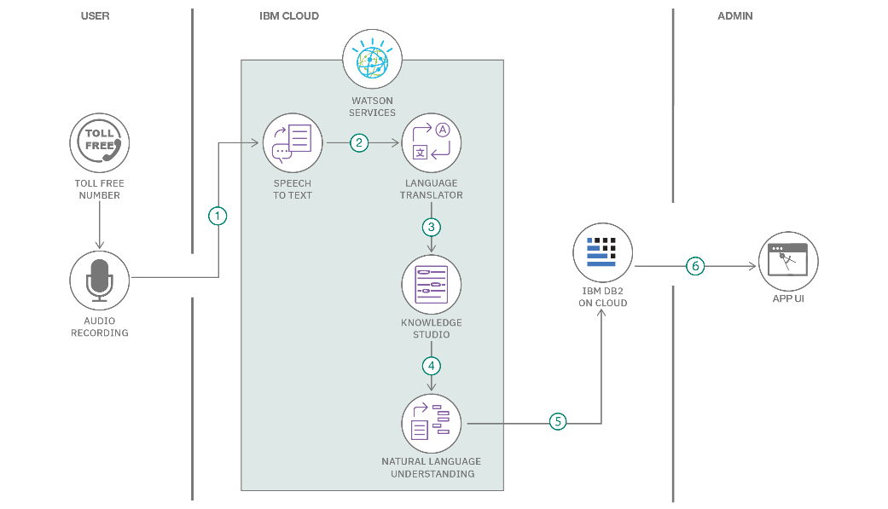

**ToyCraft_Tales : Tableau’s vision into manufacturer data**

**Table-1 : Components & Technologies:**

|  |  |  |  |
| --- | --- | --- | --- |
| **S.No** | **Component** | **Description** | **Technology** |
| 1 | User Interface | Web UI where user accesses Home, Dashboard, Story, Charts through ngrok public URL | HTML, CSS, Bootstrap, Jinja2 Templates (Flask) |
| 2 | Application Logic-1 | Handles form submissions, email validation, user navigation between pages | Python (Flask Framework) |
| 3 | Application Logic-2 | Sends welcome emails to valid emails using SMTP service | Python smtplib / Flask-Mail |
| 4 | Application Logic-3 | Embeds Tableau dashboards, charts, and stories in web UI | Tableau Public embed, Flask integration |
| 5 | Database | Stores contact form data (name, email, phone); MySQL setup for structured data | MySQL |
| 6 | Cloud Database | Not applicable — data is stored in local or hosted MySQL (can be cloud MySQL if deployed on cloud later) | (Optional: AWS RDS / Azure MySQL / Google Cloud SQL) |
| 7 | File Storage | No file storage requirement — data is structured in DB and visualizations are embedded | N/A |
| 8 | External API-1 | Not applicable in current scope | N/A |
| 9 | External API-2 | Not applicable in current scope | N/A |
| 10 | Machine Learning Model | Not applicable — no ML models in current scope | N/A |
| 11 | Infrastructure (Server / Cloud) | Local Flask server exposed via ngrok tunnel for public access. Could be deployed on cloud (optional). | Local: Flask + ngrok; Cloud: AWS EC2 / Heroku / GCP (if migrated) |

**Table-2: Application Characteristics:**

|  |  |  |  |
| --- | --- | --- | --- |
| **S.No** | **Characteristics** | **Description** | **Technology** |
| 1 | Open-Source Frameworks | Flask (Python web framework), Bootstrap for styling, MySQL | Flask, Bootstrap, MySQL |
| 2 | Security Implementations | Basic form input validation, email validation, could add HTTPS via ngrok / server config, optional JWT for sessions | Email validation, Flask form validation, ngrok HTTPS tunnel |
| 3 | Scalable Architecture | Can be scaled to microservices (Flask APIs + separate Tableau embed + DB service) or 3-tier architecture | Flask app + DB tier + Tableau as presentation tier |
| 4 | Availability | Currently dependent on Flask + ngrok uptime; can improve via cloud deployment and load balancer in future | ngrok tunnel; cloud options: AWS/GCP/Heroku with load balancer |
| 5 | Performance | Designed for small-medium user load; performance could be optimized with caching (Flask-Caching) and CDN for static assets | Flask server, Tableau Public (visual loads), potential CDN for static files |